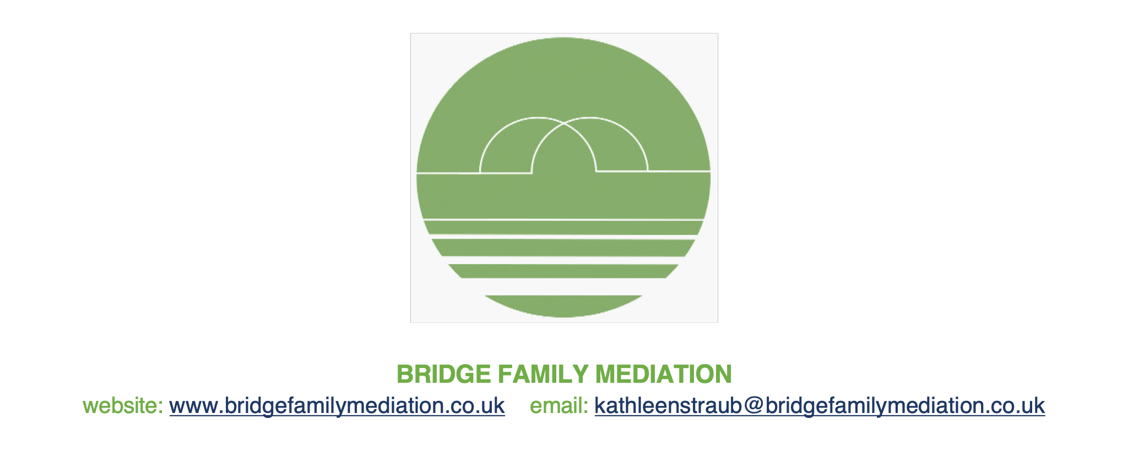

**PRIVACY POLICY**

This privacy policy relates to Bridge Family Mediation and it explains how our mediation service uses (or ‘processes’) the personal data you share with us.

**Who is covered by this policy?**

* People who mediate with us, and their families
* People who contact us to explore the possibility of mediating with us
* People who may be invited to explore the possibility of mediating with us, because someone connected with them has contacted us to explore the possibility of mediating with us

**What personal data is involved?**

Our mediation clients (and prospective mediation clients) provide us directly with almost all of the data we process. The only exceptions are a) when data is provided by solicitors or some other professionals (at the clients’ request or with their consent) or b) when someone who is interested in resolving an issue by mediating provides us with an email address or other contact information so that we can offer the other person a meeting to explore whether or not mediation might be a good way forward.

**How is the personal data gathered?**

We collect and process data when you contact us using an email address or by telephone (unless you block the actual number you are calling on), or when you use our website contact form.

We collect and process data while exploring with you whether or not mediation is a real option for your family.

We also collect and process personal data during the mediation process itself – including but not limited to personal financial and health data. The data collected sometimes includes personal data about children over 13 but we consider that it is not proportionate to contact every child over 13 with a separate privacy notice about the limited information we hold about them.

We also collect and process personal data during child-inclusive mediation sessions (during which we meet directly with young people). Our invitations to a child over the age of 13 do include an age appropriate privacy notice.

**What control do you still have over your data?**

Your information can only be shared outside the mediation process with your knowledge and prior consent (unless we are required to share it with someone in order to meet our professional obligations as mediators registered with the Family Mediation Council – this exception is explained in more detail below).

We will handle your personal data only in ways you would reasonably expect and we will not do anything unlawful with the data.

You are entitled to access the personal data we hold about you, within one month of our receipt of your request. We will provide a copy of the information free of charge, although we are entitled to ask for a reasonable fee or payment to cover the cost of producing such information when a request is manifestly unfounded or excessive, particularly if it is repetitive. We may also charge a reasonable fee to comply with requests for further copies of the same information. In all cases any fee charged will be based on the administrative cost of providing the information.

However, if data contains information about another person, such information cannot be provided without that other person’s permission.

You are entitled to have inaccurate personal data rectified.

You are entitled to have the information deleted (“erased”). The right to have information deleted applies if the personal data is no longer necessary for its original purpose – if you want us to delete your data, that is very likely to mean that mediation isn’t suitable or is no longer possible.

You also have a limited right to ‘restriction’ of your data within one month of our receipt of your request, which might for example, permit the data to be held on file for complaints or other purposes, but not used in any other way, for example, by sending you an email. You can also ask us to give you a copy of your data in a format that allows you to use it elsewhere – data portability – again within one month of our receipt of your request.

**What do we do with your data and why is it legal for us to use it?**

As family mediators, we are ‘processors’ of personal data for the purposes of the General Data Protection Regulation. Processing (or using) personal data always has to be for a legitimate purpose - our purposes all relate to mediation, either providing our mediation services to people who have signed our Agreement to Mediate, or giving families the opportunity to find out more about family mediation as a way of resolving a family issue. In order to provide these mediation services as accredited family mediators, we also have to comply with the professional obligations imposed on us by the Family Mediation Council. These include obligations to make your personal data available to other people in certain limited circumstances. Our practice supervisors, a complaints handler or the Legal Aid Agency may have sight of our files (as explained below) but access is strictly controlled and on a confidential basis.

*If you decide to mediate with us*, we ask you to consent to us processing your personal data by signing our Agreement to Mediate. If you sign our Agreement, you consent to us processing your personal data as part of your contract with us – our legal basis for processing your data if you are mediating with us is contract. This includes us retaining and storing your personal data for as long as is necessary in connection with the Agreement, to include a period of 2 years after the mediation concludes, in case of complaint. It also includes giving us permission to share your personal data with our practice supervisors and/or any person appointed by the Family Mediation Council to consider a complaint about the mediation We may retain data for research and statistical purposes, but only on the understanding that if used for this purpose all identifying details will have been removed. We will not process your data for any other purpose.

*Before this, while you and we are working out whether or not mediation is a good option for your family*, we will usually process a very limited amount of your personal data, for example your contact details, so that we can communicate with you and assess your suitability for family mediation.

*If you have contacted us*, we are able to process your personal data for the limited purpose of exploring with you whether or not mediation is a good way forward for your family. Because you have contacted us, asking us to do this, our legal basis for processing the very limited personal data that you give us is still contract (even though you have not yet signed the Agreement).

*If you have not contacted us*, we are only able to process your contact details (usually an email address or phone number) in order to offer you the opportunity to explore family mediation as an option. In this case our legal basis for processing your personal data is the public task of giving families access to mediation as an alternative to litigation. The Children and Families Act 2014, s 10, introduced a mediation information and assessment process and requires the majority of people to show that they have attended a mediation information and assessment meeting, and have considered family mediation as an option, before they ask the court to make a decision about their family. Contacting someone to give them access to this mediation information and assessment process is therefore a way to protect their legal rights within the family justice system.

October 2022